

**Kindergarten – Second grade**:

Format: Coloring sheet contest

Theme: Map of physical elements- land, rivers, and mountains or Ways of transportation as related to the battle of Point Pleasant.

**Kindergarten – Second grade**:

Format: Coloring sheet contest

Theme: Map of physical elements- land, rivers, and mountains or Ways of transportation as related to the battle of Point Pleasant.

* All submissions must be received by: ___________.
* Please visit the following website for further details: [For West Virginia Students - America250WV : America250WV](https://america250wv.org/for-west-virginia-students/)
* Please visit the following web[aaron.p.parsons@wv.gov](mailto:aaron.p.parsons@wv.gov)
* site for further details: [For West Virginia Students - America250WV : America250WV](https://america250wv.org/for-west-virginia-students/)

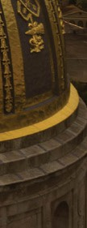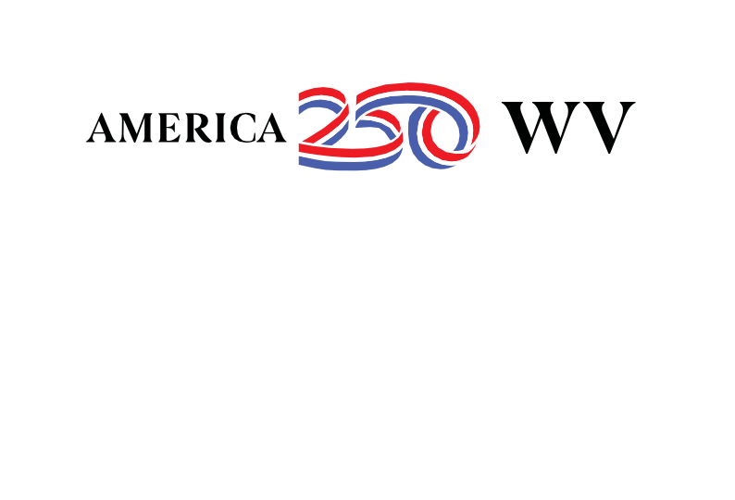

**Secondary (grades 6-12) Schools**

To celebrate the 250th anniversary of the signing of the Declaration of Independence, the organization, America250, is working to engage every American in commemorating the 250th anniversary of our country. The state of West Virginia is excited to join in this celebration.

* Preparation for the celebration will run from 2024-July 4, 2026.
* The West Virginia celebration is made possible through a partnership between the state of West Virginia, West Virgnia Department of Arts, Culture, and History, Marshall University, the West Virginia Department of Education, West Virginia state parks, and West Virginia University.
* The 250th celebration will begin with a focus on the Battle of Point Pleasant and West Virginia secondary school students are invited to participate in our poster or essay contest.

**Grades 6-8:**

Format: Poster contest

Theme: The Battle of Point Pleasant

Guidelines: All work should be completed individually. Poster should be no larger than 24 inches wide and 24 inches high. Posters can be created through any of the following mediums: oil, acrylic or watercolor paint, colored pencil, pencil, ink, marker, pastels or charcoal, collage, or mixed media (2 or more of the above listed.) A student information form must accompany the coloring sheet.

**Grades 9-12:**

Format: Essay contest

* Theme: Should the Battle of Point Pleasant be considered the first battle of the American Revolution? Why or why not?
* Guidelines: All work should be original. All work should be completed individually. Minimum word count: 500 words, essay should be typed or written neatly in pen.
* **Deadline:** All submissions must be submitted to Dropbox by: ___________.

Submissions should be mailed or delivered to the following address by 9/3/2024:

West Virginia Department of Arts, Culture and History

Attn: American Revolution Project Poster Contest

1900 Kanawha Blvd. East

Charleston, WV 25305

* Please contact [Aaron Parsons](mailto:aaron%20parsons) with questions and visit the following website for further details and contest rubrics: https://america250wv.org/for-west-virginia-students/.

AMERICA 250 | WEST VIRGINIA

1900 Kanawha Blvd. East | CHARLESTON, WV 25 305 | 304-558-0230| <https://america250wv.org>