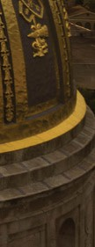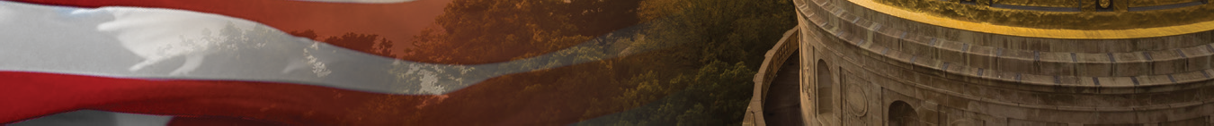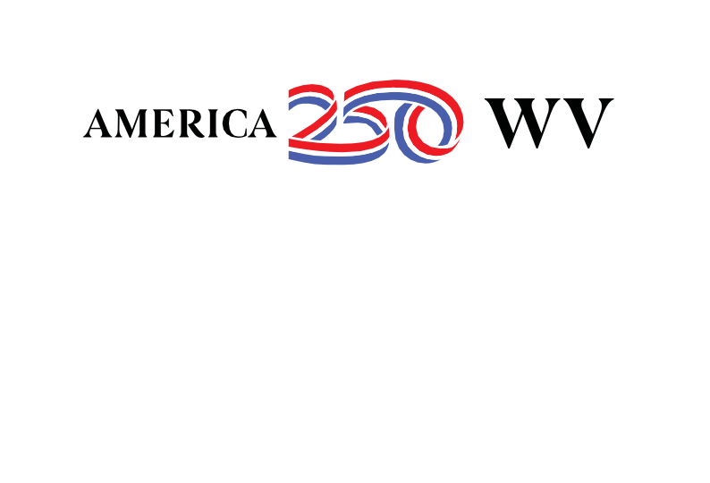

**Elementary (K-5) Schools**

To celebrate the 250th anniversary of the signing of the Declaration of Independence, the organization, America250, is working to engage every American in commemorating the beginning of our country. West Virginia is excited to join in this celebration.

* Preparation for the celebration will run now - July 4, 2026.
* The West Virginia celebration is made possible through a partnership between the state of West Virginia, the West Virgnia Department of Arts, Culture, and History, Marshall University, the West Virginia Department of Education, West Virginia State Parks, and West Virginia University.
* The 250th celebration will begin with a focus on the Battle of Point Pleasant, and West Virginia elementary school students are invited to participate in our coloring or drawing contest.

**Kindergarten - Second grade**:

Format: Coloring sheet contest

Theme: Cabin at Tu Endie Wei State Park, Point Pleasant, WV

Guidelines: All work should be completed individually. Coloring can be done using colored pencil, pencil, ink, marker, or mixed media (2 or more of the listed options). A student information form must accompany the coloring sheet.

**Third - Fifth Grade:**

Format: Drawing contest

Theme: The difference between settlements throughout the Point Pleasant area as related to the Battle of Point Pleasant

Guidelines: All work should be original in concept and design and completed individually. The drawing can be no larger than 24 inches wide and 24 inches high. It can be done using colored pencil, pencil, ink, marker, or mixed media (2 or more of the listed options). A student information form must accompany the drawing.

**Submissions should be mailed or delivered to the following address by 9/3/2024:**

West Virginia Department of Arts, Culture and History

Attn: American Revolution Project Poster Contest

1900 Kanawha Blvd. East

Charleston, WV 25305

* Please contact [Aaron Parsons](mailto:aaron.p.parsons@wv.gov) with questions and visit the following website for further details and contest rubrics: <https://america250wv.org/for-west-virginia-students/>

AMERICA 250 | WEST VIRGINIA

1900 KANAWHA BLVD. EAST | CHARLESTON, WV 25 305 | 304.5 58. 0230 | <https://america250wv.org>